TO: Chief Thomas Stangrecki, Pittsburgh Acting Chief of Police

FROM: Victoria Burford, Crime Analyst  
DATE: May 8, 2023  
SUBJECT: Crime Analysis Performed on Public Dataset

Arrests in the municipality of Pittsburgh are closely related to personal demographics, including race and age, geographic demographics, including median income and population, and trends over time, including hourly and yearly trends. The following is a summary of those relationships.

**The Data**

Two sources were used for this analysis. The first was the [Pittsburgh Police Arrest Dataset](https://data.wprdc.org/dataset/arrest-data), found on the Western Pennsylvania Regional Data Center. This dataset included data on every arrest made in Allegheny County from September 1, 2016 to April 12, 2023. Each arrest contained data on the offense(s), the characteristics of the person being arrested (age, race, gender), the date and time of the arrest, and where the arrest was made, including the exact address, the neighborhood, and the police zone the arrest was made in. This dataset was then filtered to include only arrests made in Allegheny County.

The second source of data for this analysis was the U.S. Census API (Application Programming Interface), from which data on Pittsburgh population, race, and income demographics were collected at the tract level from the 2020 Census.

**Summary Statistics**

By Race: 61.7% of all arrests made from Sept. 2016 – April 2023 were black, 35.0% were white, and 3.3% were non-black and non-white.

By Age: 5.8% of all arrests were minors, 40.0% were young adults (older than 18 and younger than 30), 51.1% were middle-aged (over 30 and under 65), and 0.12% were senior citizens (61+).

By Time of Day: The most arrests occurred from 16:00 – 18:00 hours (18.9% of all arrests) and 01:00-02:00 (9.7% arrests). The least arrests were made from 04:00 – 07:00 (6.5% of arrests).

By Zone:

Police Zones are demarcated as demonstrated in the visual below. Income was collected at the tract-level (also depicted in the visual) and averaged for all zones.



For a complete breakdown of the percent of all arrests by police zone, please see the bar graph below. To see the average median income and average population size across all the tracts included each zone, see the table below.





Of Note: Zones 4 and 6 make up the smallest percentage of arrests despite having the largest populations. Additionally, Zones 4 and 6 have the highest mean incomes of all the zones.

**Trends**

The total number of arrests being made has been steadily falling since 2017 (the first complete year of the dataset). On average, every year since 2017 has seen 2.8 fewer arrests per day than the year before, or 1,427 fewer total arrests than the year before.

The number of violent-crime arrests—defined as arrests with offenses including assault, robbery, or voluntary manslaughter—made per year have also been decreasing, though at a rate slower than the total arrests. Because of this, violent crime has been making up an increasing proportion of arrests, going from 27.8% of all arrests in 2017 to 32.0% of all arrests in 2022.

The number of arrests of black residents has also not be decreasing as quickly as the number of arrests of white residents. Because of this, an increasing proportion of arrests made were of black residents. In 2017, 57.9% of all arrests made were black. By 2022, 64.8% of all arrests made were black. So far in 2023, 68.8% of all arrests have been of black residents.

**Violent-Crime Arrest Characteristics**

A linear regression model was built to determine the factors related to violent offenses. A linear regression model is a mathematical way to describe the relationship between a variable of interest—in this case the proportion of all arrests that include violent offenses—and potentially related variables—in this case police zone of the arrest, year, season, and race.

For the full regression model results, see the last page of this memorandum. For a written summary of the results, see below.

Zones:

Zone 1 was used as the baseline for proportion of violent-crime arrests. Zones 3 and 6 have the greatest difference in violent-crime arrests from Zone 1. Zone 3 is associated with a 6% increase in the proportion of violent-crime arrests and Zone 6 is associated with a 12% increase in the proportion of violent-crime arrests.

Notable about these results is that Zone 6 was also the zone with the lowest total arrests. However, Zones 3 and 6 do have the largest populations. This suggests that violent crime follows a different trend than non-violent crime. While it appeared that differences in overall crime—whose trend was dominated by non-violent crimes—across zone was being primarily driven by average income in each zone, violent-crime arrests appear to be more driven by average population in each zone.

It is possible that there is also a weaker—but still present—relationship between income and violent-crime, but the data would have to be re-structured and scaled by population for this relationship to appear.

Year:

The regression confirms that the proportion of violent-crime arrests has been growing since 2017. The passing of 1 year is associated with a 0.36% increase in the proportion of arrests that include a violent crime.

Race:

There is a significant difference between minority residents and white residents. Being white is associated with a decrease in probability of being arrested for a violent crime of 12.1%.

It is important to note that income data is not included in this regression. This is important because income and race are heavily correlated, and it has already been noted that income and violent-crime arrests may correlate. This means that some of the differences being attributed to race may actually be coming from differences in income.

It would be possible to match tract-level income to the coordinates of the arrest to incorporate income if a similar analysis was performed in a larger timespan, however doing so was too computationally expensive for the purpose of this analysis.

**Opportunities for Future Research**

As noted above, in a more in-depth study it would be useful to gain income data at the individual-level if possible, and the tract level if not. It would then be possible to be confident in what amount of the arrest rates are related to race as compared to income.

Additionally, more research could be done into the characteristics of the police departments manning each zone, to see if there is any potential difference in arrest rates coming from police-department characteristics as opposed to solely tract-level characteristics.

One final opportunity for further study would be to look at the interaction between police engagement and crime. Unfortunately, the dataset on police department community engagement available on the Western Pennsylvania Regional Data Centeronly contained data from the year 2016, before the publicly available arrest-record data began. If there is a record of community engagement activities that is not publicly available, it would be possible to see if specific community engagement activities have the potential to decrease arrest rates.

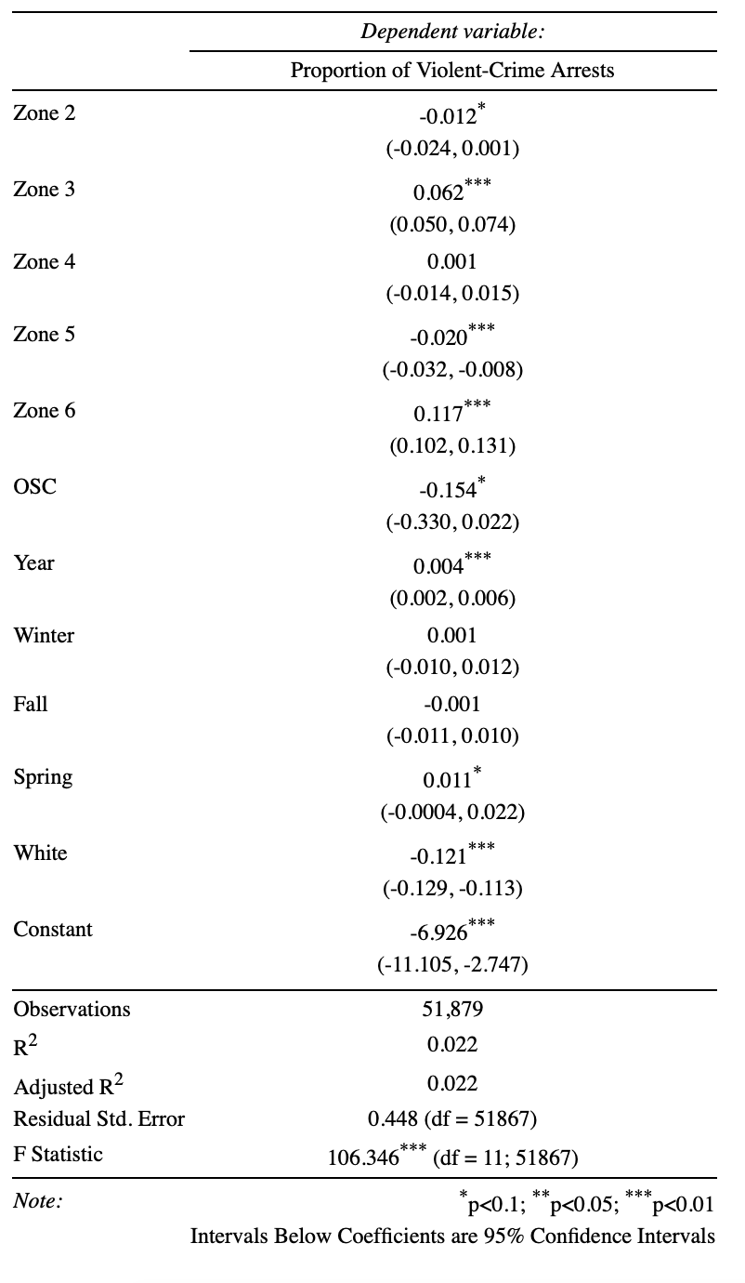

**Linear Regression Model Predicting Violent-Crime Arrests**